Terms of Reference
Economic Analysis of Biodiversity and Ecosystem Services in Mozambique
Complementary analytical input to the Green Deal Team Europe Initiative (GD-TEI) Political Economy Analysis

Background and Rationale

Grean Deal Team Europe Initiative
Team Europe (TE) consists of the EU, its Member States and their diplomatic network, finance institutions and implementing organisations, as well as the EIB and the EBRD. The Team Europe approach is a way of strengthening coordination, coherence and complementarities of actions to scale up European impact and raise Europe as partner of reference. In Mozambique, two Team Europe Initiatives, Green Deal for Mozambique (GDTEI) and E-Youth TEI, have been developed during the first semester of 2020.
The key areas of intervention (pillars) of the GDTEI are:
- Biodiversity – enhancing the protection, preservation, and sustainable management of biodiversity, forests, and ecosystems;
- Energy – promoting renewable energy sources and enhancing sustainable energy infrastructures;

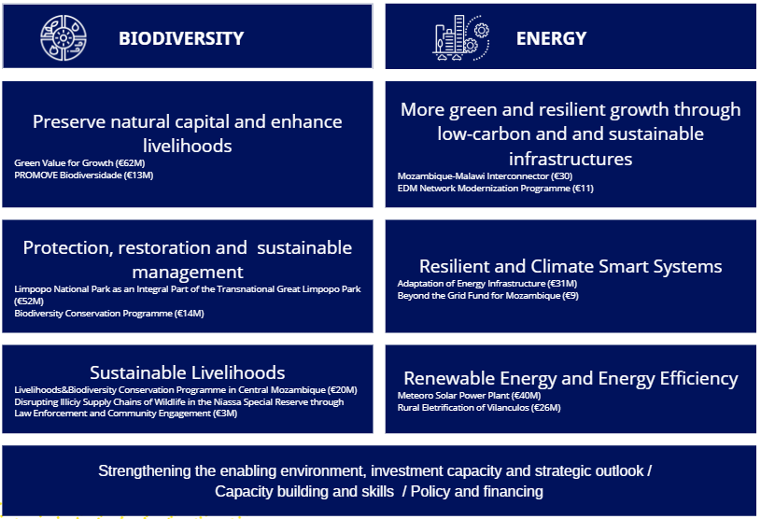Figure 1 - Overview of the TEI

The Political Economy Analysis
In parallel, a comprehensive Political Economy Analysis (PEA) covering the biodiversity and energy sectors is being undertaken to inform strategic policy dialogue, EU engagement, and programming.
While the PEA focuses on institutions, stakeholders, power dynamics, and incentives, there is a recognised need for a robust, policy-oriented economic analysis that quantifies and explains:
- The financial and economic importance of biodiversity and ecosystem services to the national economy
- The economic linkages between biodiversity/ecosystem services and key productive sectors such as agriculture, fisheries and tourism;
- The contribution of ecosystem services to livelihood assets, notably water resources, food security, and climate resilience.
This assignment will generate an economic evidence base to complement the PEA and strengthen policy messaging, reform arguments, and investment prioritisation under the GD-TEI.

2. Overall Objective
To produce a policy-relevant economic analysis of biodiversity and ecosystem services in Mozambique, demonstrating their financial value, cross-sectoral economic contributions, and importance for livelihoods.

3. Specific Objectives
The assignment will:
- Analyse the economic contribution of biodiversity and ecosystem services to Mozambique’s economy, including, as applicable, direct, indirect, and induced effects.
- Assess the value of ecosystem services provided as public goods, including regulating, provisioning, and cultural services that are not fully captured by markets.
- Quantify and/or qualitatively assess economic linkages between biodiversity and:
  - Agriculture and food systems;
  - Tourism and nature-based tourism;
  - Water resources management and hydrological services.
- Examine the role of biodiversity in sustaining livelihoods, with particular attention to rural communities, food security, and vulnerability reduction.
- Identify economic externalities, trade-offs, and opportunity costs associated with biodiversity loss versus conservation.
- Provide clear, decision-oriented messages that can be directly used in the PEA’s analysis, synthesis note, and high-level policy dialogue.

4. Scope of Work
The analysis shall cover, at minimum:

4.1 Thematic Scope
- Terrestrial, coastal/marine, and inland water ecosystems (aligned with the NBSAP ecosystem typology).
- Ecosystem services, including , where feasible:
  - Water regulation and supply;
  - Soil fertility and erosion control;
  - Pollination and agricultural productivity;
  - Fisheries and coastal protection;
  - Carbon sequestration and climate regulation;
  - Cultural and tourism services.

4.2 Economic Scope
- If and where data allows, National-level macroeconomic relevance (GDP linkages, fiscal relevance).
- Sectoral focus on agriculture, fisheries and touris.
- Livelihood-level impacts (income, subsistence, resilience).

4.3 Geographic Scope
- National-level analysis, with, if available in literature, illustrative case examples from protected areas, landscapes, or seascapes where data and evidence are available.

5. Methodology
The consultants are expected to apply sound environmental and resource economics approaches, proportionate to data availability and policy needs, including:
- Desk review of:
  - National accounts, sector strategies, and economic statistics;
  - Existing valuation studies (national and regional);
  - BIOFIN, conservation finance, and ecosystem service assessments;
  - International literature relevant to Mozambique and Southern Africa.
- Economic valuation approaches, as appropriate:
  - Use and non-use values;
  - Benefit transfer where primary valuation is not feasible;
  - Cost-based and avoided-damage approaches;
  - Qualitative valuation for non-quantifiable services.
- Cross-sectoral linkage analysis, highlighting dependencies, risks, and co-benefits.
- Close coordination with the PEA team, including:
  - Alignment of assumptions and terminology;
  - Iterative sharing of preliminary findings;
  - Tailoring outputs to feed directly into the PEA report and synthesis note.
Methodological ambition should be policy-oriented rather than academic, prioritising clarity, credibility, and usability.

6. Deliverables
The consultant(s) will deliver:
- Inception Note (approx. 3 pages)
  - Analytical framework, data sources, valuation approaches;
  - Clear articulation of how outputs will integrate with the PEA.
- Technical Economic Analysis Report (approx. 25 pages, annexes allowed)
  - Economic contribution of biodiversity and ecosystem services;
  - Sectoral and livelihood linkages;
  - Key quantitative results and qualitative insights;
  - Limitations and confidence levels.
- Policy-Ready Synthesis Note (3 pages max)
  - Key economic messages for decision-makers;
  - Graphics/tables suitable for direct reuse in the PEA;
  - Framing aligned with policy dialogue and reform incentives.
- Presentation (PowerPoint)
  - For internal validation and integration discussions.

7. Team Composition and Qualifications
The assignment may be carried out by:

Option A: One Senior Expert
- Senior environmental / ecological economist with at least 15 years of experience.

Option B: Two Complementary Experts (preferred)
- Environmental / Resource Economist
  - Expertise in ecosystem service valuation and environmental public goods.
- Sector / Development Economist
  - Experience in agriculture, fisheries, tourism, livelihoods, or water economics.

Required Qualifications
- Advanced degree (Master’s or PhD) in Economics, Environmental Economics, Natural Resource Economics, or related fields.
- Demonstrated experience with ecosystem services valuation and policy-oriented economic analysis.
- Prior work in Mozambique or Southern/Eastern Africa strongly preferred.
- Ability to translate complex economic findings into clear policy narratives.
- Fluency in Portuguese and English
- Experience working alongside governance or PEA teams is an asset.

8. Timeline and Level of Effort
- Total duration: aligned with the PEA timeline (indicatively 8-10 weeks).
- Level of effort:
  - Total working days: ~20 working days
  - Exact phasing to be agreed to ensure timely integration with PEA milestones.

9. Reporting and Coordination
- The consultants will report to the GD-TEI Facility / Contracting Authority.
- Day-to-day coordination will be ensured with the PEA Team Leader.
- All outputs remain confidential and are intended for internal analytical and policy dialogue purposes.

10. Quality Standards
Deliverables must be:
- Evidence-based and methodologically transparent;
- Consistent with national data and policy frameworks;
- Written in clear, non-technical language suitable for senior decision-makers;
- Directly usable within the PEA and related policy products.

